The Feature Management screen allows authorized platform administrators and product teams to define and maintain the catalogue of capabilities, features, modules, functions, and access packages offered through Compass.
The screen maintains the hierarchical relationship between:
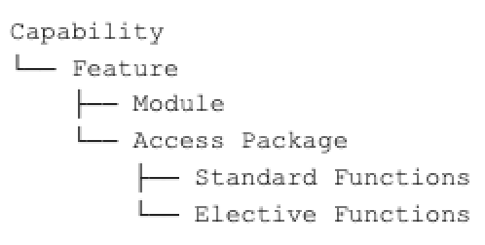
The Feature Management catalogue represents what Compass offers in consistent business terminology. It does not independently define the roles, permissions, profiles, groups, or technical resources used by each integrated system. Those values are maintained in the System Integration Registry and selected by reference when configuring a feature.
This separation allows Compass to present one consistent product and access model while supporting different implementation models across Compass, Compass Legacy, R2, Secure Zone, NetRep, and other integrated applications. The registry material describes that distinction as a mapping between Compass functions and the roles, permissions, groups, profiles, or other assignments used to provide the equivalent access in each system.

Purpose:
The purpose of Feature Management is to establish an authoritative, reusable directory of the services and functionality available through Compass.
The directory supports platform capabilities that need to understand:
What Compass offers.
How the offering is organized into business capabilities and features.
Which Compass modules provide access to each feature.
Which functions are included automatically with an access level.
Which functions can be assigned electively.
Which system-specific permissions implement the requested access.
Whether a feature is available for use by consuming platform services.
How a feature should be identified consistently across platform experiences.

The Feature Registry currently includes product hierarchy, status, module, module resource, system, access-package grouping, and View, Manage, Control, and Process assignments.
Planned Feature Management - Use Cases:

The Feature Management function shall provide a common feature directory that can power the following platform services.
System health reporting
The system shall allow health events, incidents, degraded performance, outages, and planned maintenance to be associated with one or more registered modules.
The module is the health-reporting control point because it represents the user-recognizable entry point or major functional area within Compass. The existing system-health materials describe health events as being associated with affected Compass features and presented through a centralized status experience.
The directory shall provide:
The English and French name displayed in system-health messages.
The feature and capability context for the affected module.
The module lifecycle status.
The applicable system or integration.
A stable identifier that can be referenced by monitoring and incident-management services.
Notification subscription and delivery
The system shall allow notification topics and events from any integrated system to be associated with registered Compass capabilities, features, modules, and functions.
This association allows users to subscribe to notifications using Compass terminology even when the originating event is produced by another application.
For example:
Capability: Order Management
Feature: Orders
Module: Orders
Function: Manage Equity Orders
Event source: Trading system
Notification topic: Equity order rejected
Feature registration material identifies notifications, events, health checks, and system integrations as platform concerns that should reference the same stable feature definition rather than maintain separate representations.
Feature-access requests
The system shall provide the catalogue used to render feature-access options in user creation and modification requests.
Security Stewards shall see business-oriented capabilities, access levels, modules, and functions. The platform shall use the registry relationships to translate those selections into:
Compass module access.
Standard functions.
Elective functions.
Required system resources.
User access-package matching.
System-specific provisioning instructions.
The Unified Access Management materials describe capabilities, modules, and functions being presented at the View, Manage, Control, and Process levels, with applicable items filtered according to the selected level.
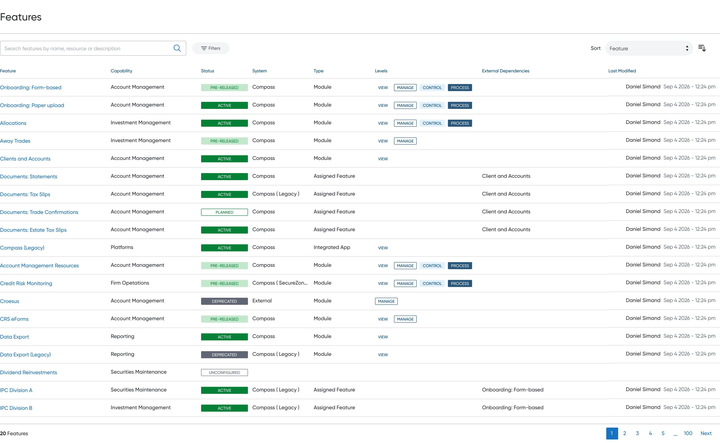

Feature name:
A Feature is a recognizable product offering, service, or functional area made available through Compass.
The feature is the central business object in the Feature Management directory. A feature belongs to one capability and may be delivered through one or more modules or integrated systems.
Examples:
Account Opening
Client and Account Inquiry
Orders
Systematic Plans
Transfer Management
CRS/FATCA Certification
The feature name is used wherever the feature is represented throughout the platform, including:
System-health status
Notification preferences
Field Summary
Label - Feature
Required
Type: 2 inputs
Placeholder 1: Feature name ( English )
Placeholder 2: Feature name ( French )
Feature Description
The Description of the feature, used internally only
Field Summary
Label - Description
Type: Text area
Placeholder: Feature Description

System: the Primary system

Type:
Feature Types:
Module - Feature that manages a full workflow
Assigned Feature - Components within the module that can be configured and included
Integrated App - Feature delivered through integrated application
External App - Feature delivered through external application
General Feature - Feature that isn’t access controlled

Capability:
A Capability is a high-level business domain that groups related Compass features.
A capability communicates the area of business activity supported by the platform and provides the primary grouping used in feature-access experiences.
Examples include:
Client Inquiry and Insights
Client Lifecycle Management
Client Servicing
Order Management
Trade Operations
Data and Reporting
User Access Management
The capability is not assigned directly to a user. Access is assigned through the packages and functions defined within its child features.
Field Summary
Label - Capability
Required
Type: Input
Placeholder: Feature’s Capability
Options:
Capability Reference Data
Each capability contains:
→ Capability ID: Unique identifier
→ Is Core: Indicates whether the capability is considered a core platform capability
→ Localized Name: Display name in the user's selected language
→ Localized Description: Description displayed in the user's selected language

